Thank you for choosing Sea Bees Tec ft Blue Label Diving.

Now you have confirmed your courses or trips and locked in your dates for your next diving trip, we would like to ask you to read, fill out and sign the documents attached.

As it is on no one’s list of favorite things to do while being on a holiday, we have added as much paperwork now, so you don’t have to do it when you arrive.

We also strongly recommend doing all of your e-learning homework (where applicable) before you arrive.

TDI E-Learning Our Store number is 100356 for everyone doing TDI courses without being a TDI diver.

To be able to process your diver/instructor application, as good and as fast as we can, we need the following forms filled out as detailed as possible.

Your personal details and every page that needs to be signed by you, including any papers with answers for exams or knowledge reviews need to be dated and named on the top of each page and need to be returned to your instructor before the end of the course.

The Student record file, student folder and e-learning need to be signed and returned on the 1st day of the course. Each course needs a separate Liability Release form from the Agency. Lets say you are doing all 3 levels of the TDI cave courses. This means 3 separate Liability release forms. The liability release form needs initials in front of each statement not a tick.

Knowledge reviews are required by the agency and should be completed before the final course day as such. You are responsible to fill them out and ask questions if any. Again, if you do this all before you arrive, you don't have to worry about and you will be able to focus solely on the diving.

The medical release forms from the agencies need to be filled our properly for legal purposes.

If you have any questions or remarks about the course it self or about our instructors, good or bad, please do not hesitate to talk to us about your concerns.

The Sea Bees Tec / Blue Label Diving Team

Delivering high quality and professional technical diving activities, with the focus on customer service, exceeding the training agency standards.

Sea Bees Tec ft Blue Label Diving strives to uplift the industry's technical diving standards, without interfering or dissociation from the established training agencies. The main goal is to offer training or diving experiences exceeding not only the industry standard, but also mainly your expectations.
The foundation of this formula lies in the art of keeping abreast of the latest industry's advancements on educational, technical and medical levels.
How we differentiate ourselves from the competition is that we pass on this know-how onto our customers, you, in a most humble and non-persuasive manner.

YOUR PERSONAL INFORMATION:
Please make sure you fill out the following details in CAPITALS

GIVEN NAME __________________________________________________

LAST NAME __________________________________________________

ADDRESS STREET ______________________________ NR ______

STATE ____________________POSTCODE ______________

CITY______________________________________________

COUNTRY _________________________________________

PHONE NUMBER __________________________________________________

DATE OF BIRTH _______/_______/________

EMAIL ADDRESS __________________________________________________

In Emergencies:
NEXT OF KIN FULL NAME __________________________________

PHONE NUMBER _____________________________

EMAIL ______________________________________

RELATIONSHIP ______________________________

Dive Information:

LAST DIVE _____________________________NUMBER OF DIVES___________DEEPEST DIVE__________MTRS

HIGEST DIVE CERT __________________________________________________

DIVE INSURANCE NAME_____________________________POLICIY NUMBER_____________________

YOUR DIVE EQUIPMENT INFORMATION:

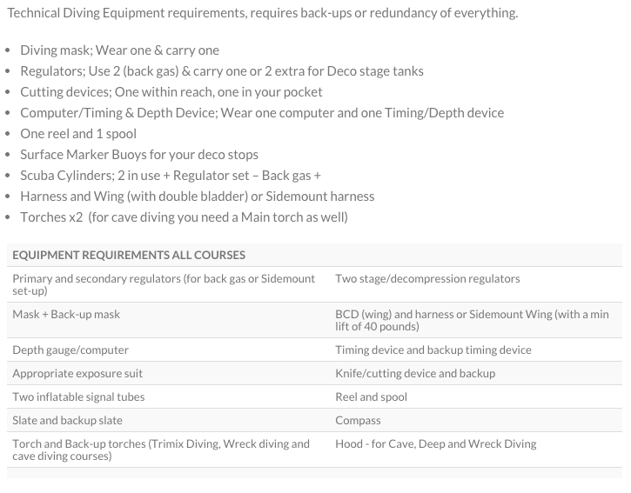
When doing technical diving courses there is no need to bring your recreational BCD and recreational Regulators. Your dive computer can be used a depth gauge and timing device.

The following items are a must have so we do require you to bring the following.
Pockets x 2 or pocket shorts
Spare mouthpiece(s)
Spare mask
SMB + spool of minimum 30 meters with double ender clip
Arm Slate or notebook
Shears or other citing device x2
O-ring kit

If you don't have these items you can buy them at our shop.

We can provide equipment for the courses Sidemount, Intro to Tec and Advanced Nitrox and Decompression Procedures. Backplate/sidemount configuration, wetsuit, regulators, fins etc if needed for a daily rental price of 1500thb

A mixed gas computer and torch rental is 300thb per day.

The pocket shorts we can sell to you for 3900thb.

Please provide us with an exact list of the equipment you will be bringing as soon as possible

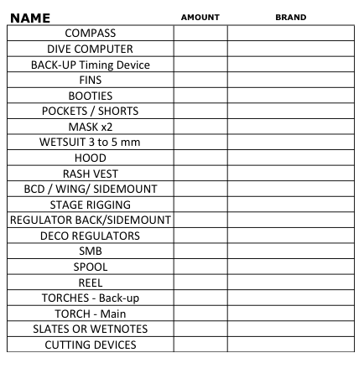

We would like to ask you for some corporation to save a lot of time when you are here and to be informed about a few important things:

1. Make sure you arrive a day before the course starts and keep the no-fly time at 24 hours for more than 1 day of diving. 1 Day of diving to max 40 meters is 18 hours minimum no fly time.

2. It’s mandatory to pay the total amount in full before you arrive. Thailand also has a lot of public holidays, which means that banks and our office staff are not open/working either. Please check this beforehand with us. We are able to charge your creditcard from here before you arrive. But we do prefer a bank transfer.

3. When using an ATM in Thailand, make sure it’s an ATM at a bank facility. ATM’s, 90% of the time only allow a max withdrawal of 20’000 THB per day.

When you are doing courses with us:
We, after you confirmed your agency profile (see below) will be able to send you your online study materials via the agency.

Please let us know if you have certification with the agency and which diver number you have with them.

If you don’t have this please go to :
• For SSI courses divessi.com - https://my.divessi.com/register
• For TDI courses tdisdi.com - portal.tdisdi.com/register?

For TDI courses: During signing up you can choose Blue Label Diving as your dive centre. After this is done, please send us an email with confirmation. We then can send the e-learning materials to you.

For SSI courses: During signing up you can choose Sea Bees Diving as your dive center. After this is done, please send us an email with confirmation. We then can send the e-learning materials to you.

The online study materials need to be finished/done before starting your course(s).

PAPERWORK

1) Student folder with your most important information (also for fun divers)
2) Medical Statement & Liability form (Student record file agency)

EQUIPMENT:
We would also like to know which equipment you will bring with you so we can determine what you will need form us or what you will need to purchase:
Have a look at our:
• EQUIPMENT REQUIREMENTS

INSURANCE:
The following are MANDATORY:
Dive Insurance, which covers Hyperbaric treatments & Travel Insurance
Please send us
• the policy number and of your insurance.

ID / Passports: send to us
• a copy of your passport
• a passport size picture is also needed for your certifications and our files.

To be able to dive on our boats or other boats we also need your Covid vaccine proof please.

FLIGHT and HOTEL:
Please send us your
• FLIGHT number
• CITY / COUNTRY you are flying from
• ARRIVAL Time and date
• DEPARTURE Time and date
• Name and address of your hotel.

Sea Bees has its own accommodation close by the dive center and the pier. The Palm Garden Resort is a bungalow style resort with its own restaurant and beautiful pool and is located in a quiet area.

Our room rates
1800 Baht per room. Rates are based on max 2 adults per room, including VAT and other charges, not including breakfast or other meals.
Children
One child under 11 years of age is staying free of charge if using the existing bedding.
Additional children will require an extra bed at 350 Baht per night.
Check-In/Check-Out times
Our check-in time is 14.00, check-out time is 12.00 noon.
Late check-out / early check-in might be possible (subject to availability) if you require this please indicate during booking!

Sea Bees Diving – Phuket Head Office
Just a few hundred metres from Chalong Pier and close to the Palm Garden Resort is our Head Office. Here we have all of our own individual departments – Front Office, Reservations, Accounting, Marketing, Public Relations and Technical – all concentrating on their work allows us to provide the best service to all our guests.
This is where we started over 20 years ago and, with our recent renovations, we now have the perfect place to welcome you!
Open every day from 8am to 8pm, come in for information on our daytrips, courses, packages, liveaboard safaris and more.
Address: 1/3 Moo 9, Viset Road, Chalong Phuket 83130, Thailand
Tel: +66 (0) 884509508
Fax: +66 (0) 76 383 132
Email: simone@bluelabeldiving.com
Opening Times: 8am – 8pm

TAXI:
We can organize this for you and have someone wait at the airport for you for 1500thb.

Thank you very much for your attention and corporation!

We are looking forward to meeting you.

The Sea Bees Tec ft Blue Label Diving Team!

